Over The Wire

## Level 18 to Level 19

**Step 1: SSH Login**

**Password: x2gLTTjFwMOhQ8oWNbMN362QKxfRqGlO**

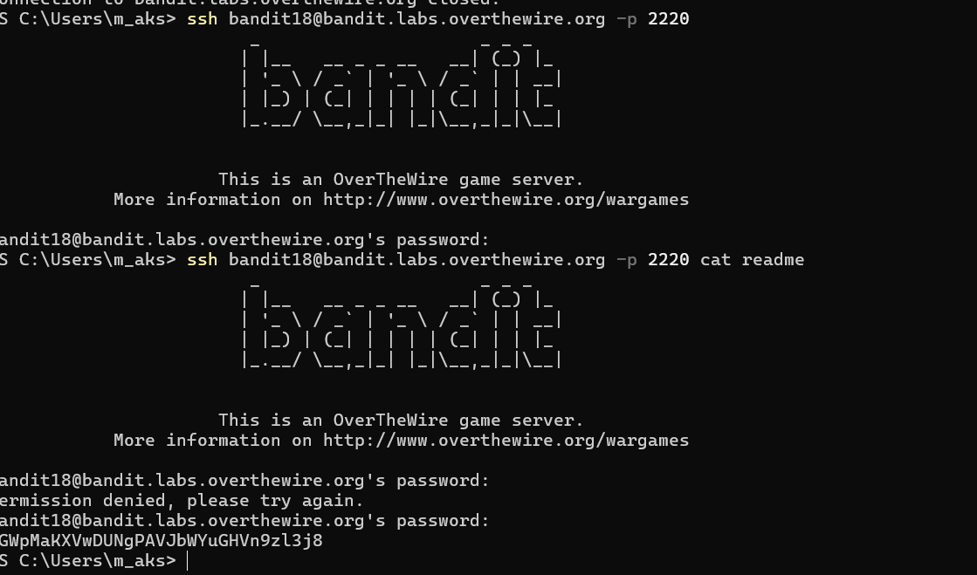

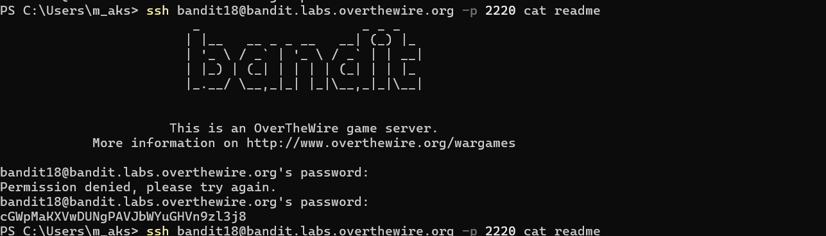

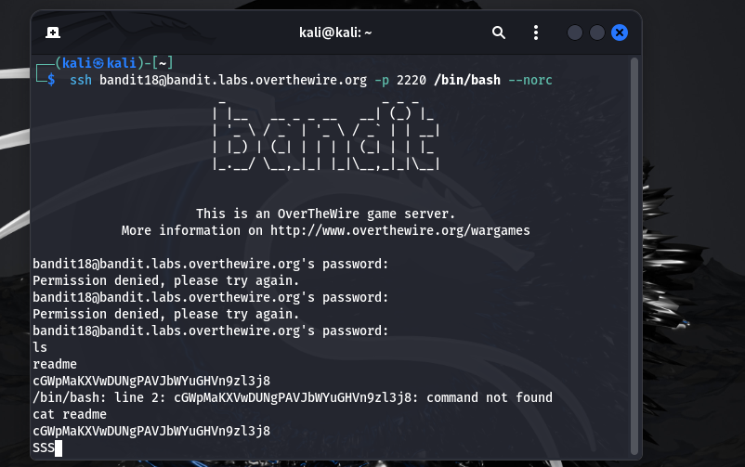

**Password:** **cGWpMaKXVwDUNgPAVJbWYuGHVn9zl3j8**